School of Frontier Mission
Please return all forms to:

YWAM Vunayasi Phone: 627-9450
PO Box 1450 Mobile: 9950892
Nadi email:ywamvunasi@gmail.com

SCHOOL OF FRONTIER MISSIONS
STUDENTS APPLICATION.

MONTH______________________________________ YEAR ________________________________________

PERSONAL AND CONTACT INFORMATION
(Name as it appears in your passport)

Mr/Mrs/Miss___________________________________________________________________________________
Last Name First Middle

Age______________________________Date of Birth _____________________________________________.

Place Of Birth__________________________________Marital Status: Single/Married/Divorced/Widowed

Sex: Male or Female

Married Couples please out separate applications. Give children’s name, age, gender on a separate paper.

Permanent Address________________________________________________________________________________
_________________________________________________________________________________________________
_____________________________________________________________________________________________________

Phone number___________________________________________________

E-mail address___________________________________________________

Passport, Nationality and Language Information
Nationality________________________________________

Passport Number___________________________________ExpiryDate____________________.

What Languages do you speak fluently? _______________________________________________
_____________________________________________________________________________.

Emergency Information:

In case of emergency contact: ___________________________________________________________

Relationship__________________________________________________

Address__________________________________________________

Phone:____________________________________________________

In case of emergency, I agree to the performance of such treatment, including anesthesia and surgery as the attending doctor, or physician may say is necessary.

Applicants Signature:______________________________________Date______________________________

Parent/Guardian
Signature:_________________________________Date_______________________________.

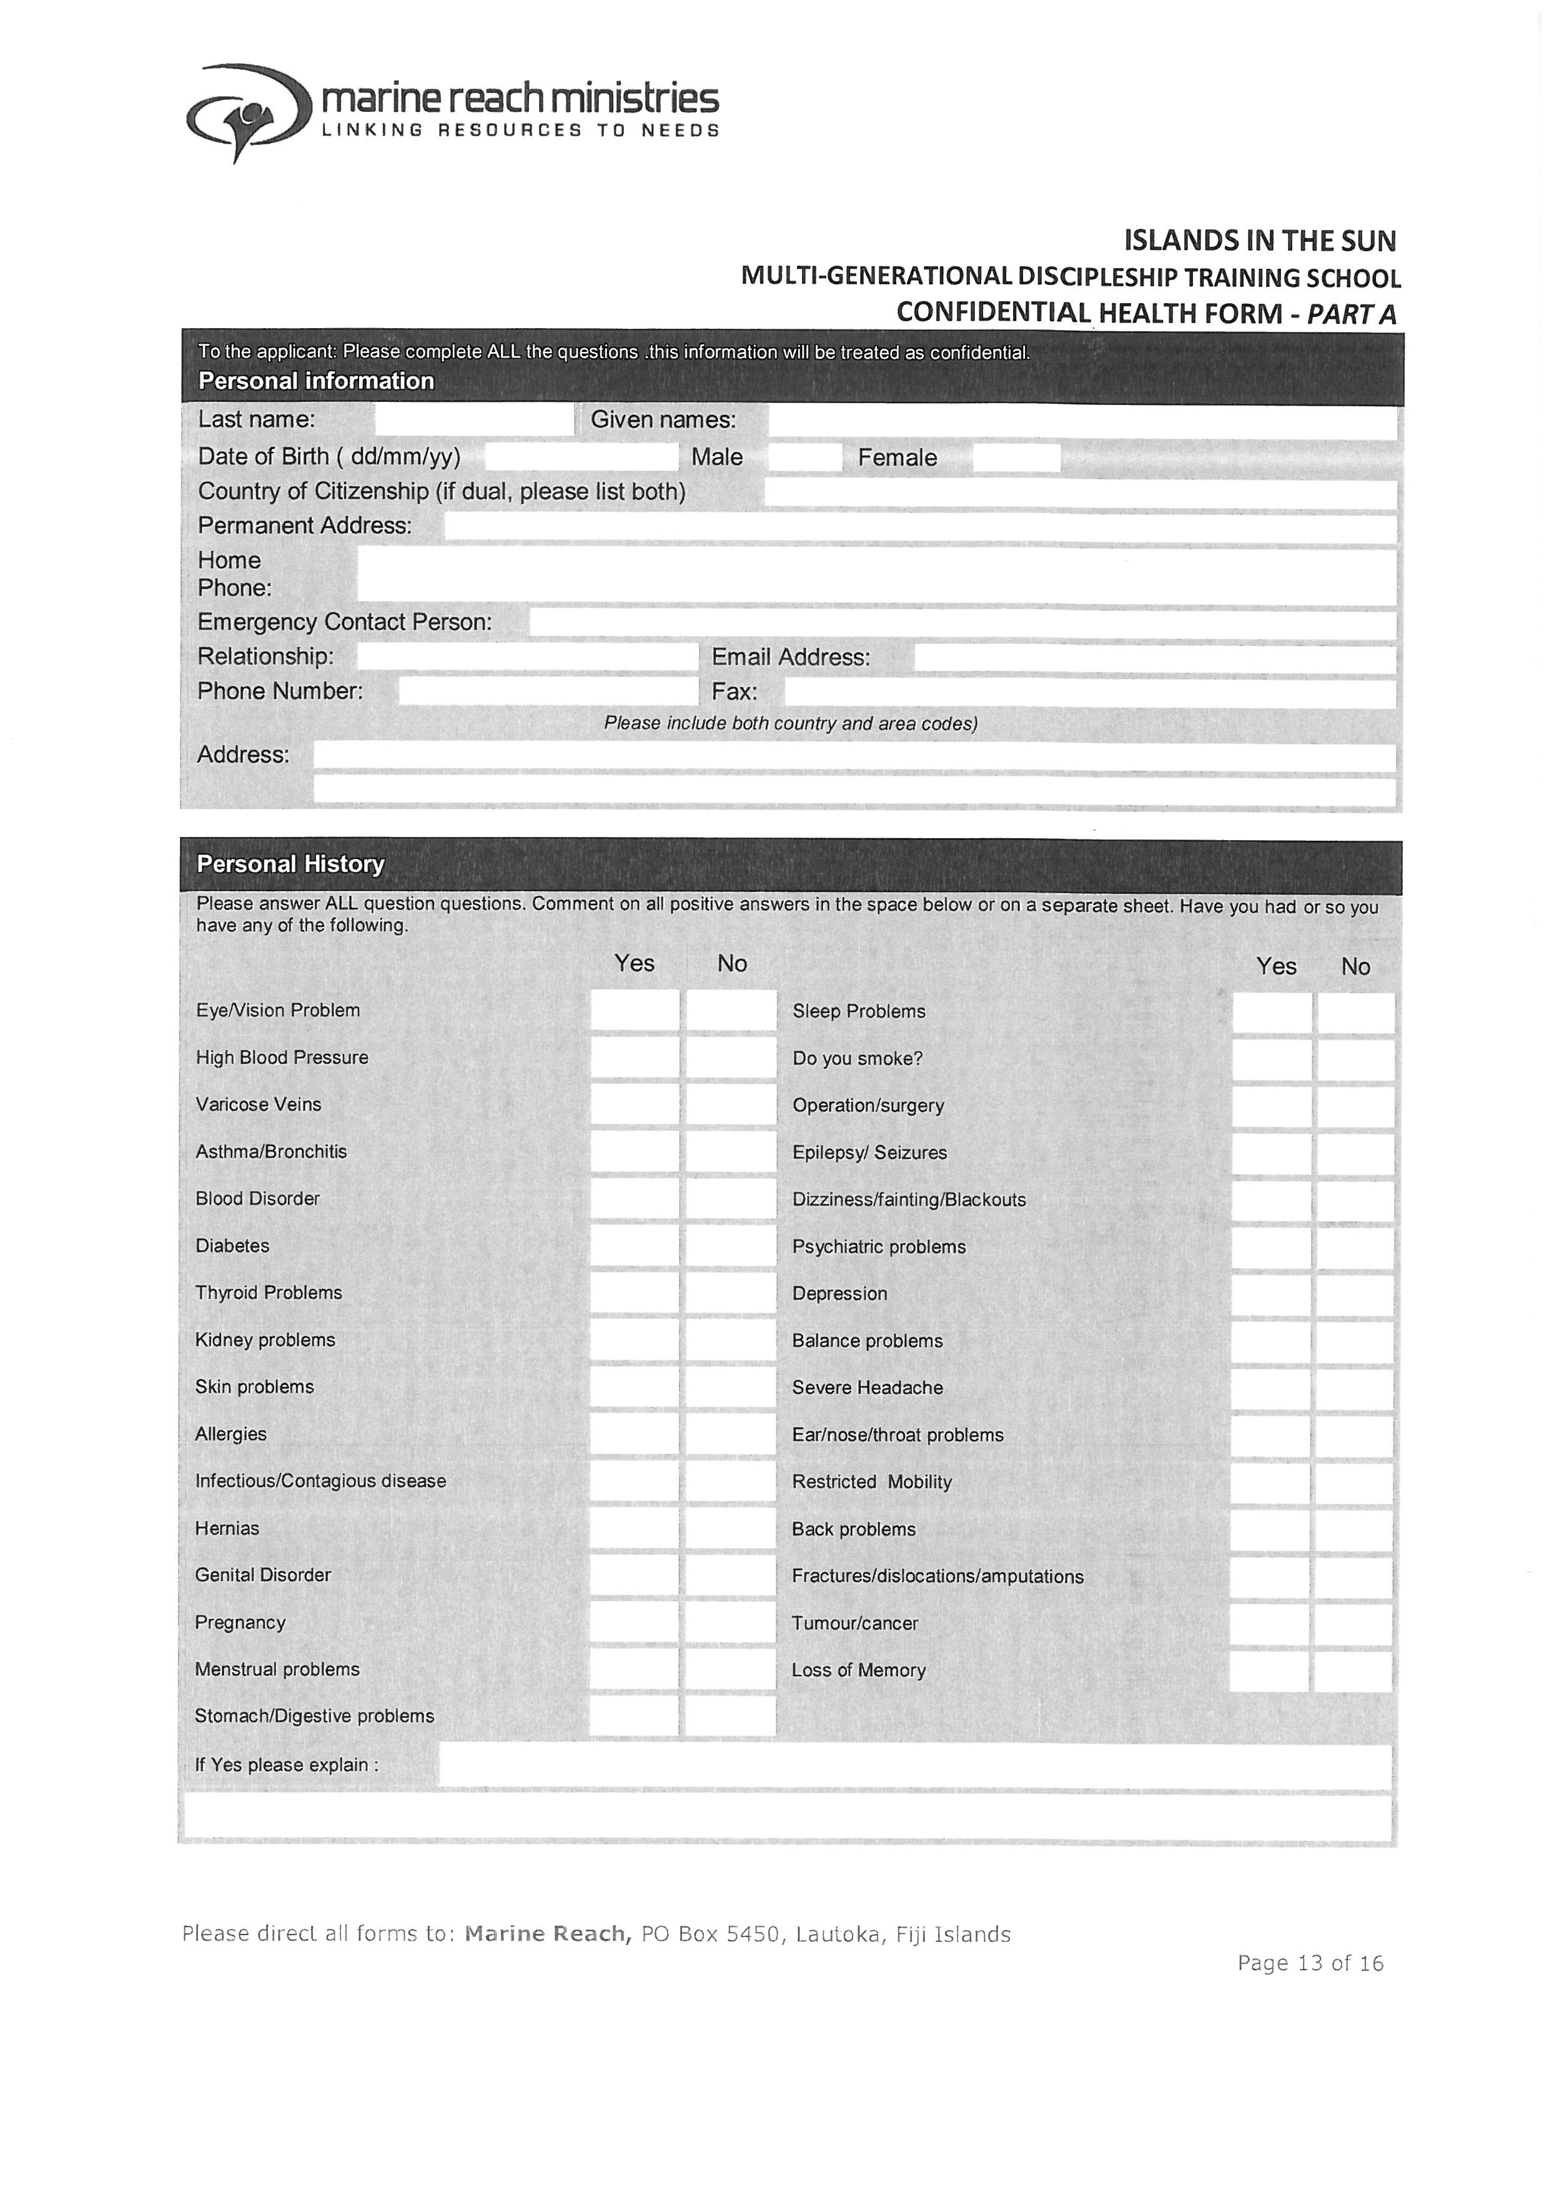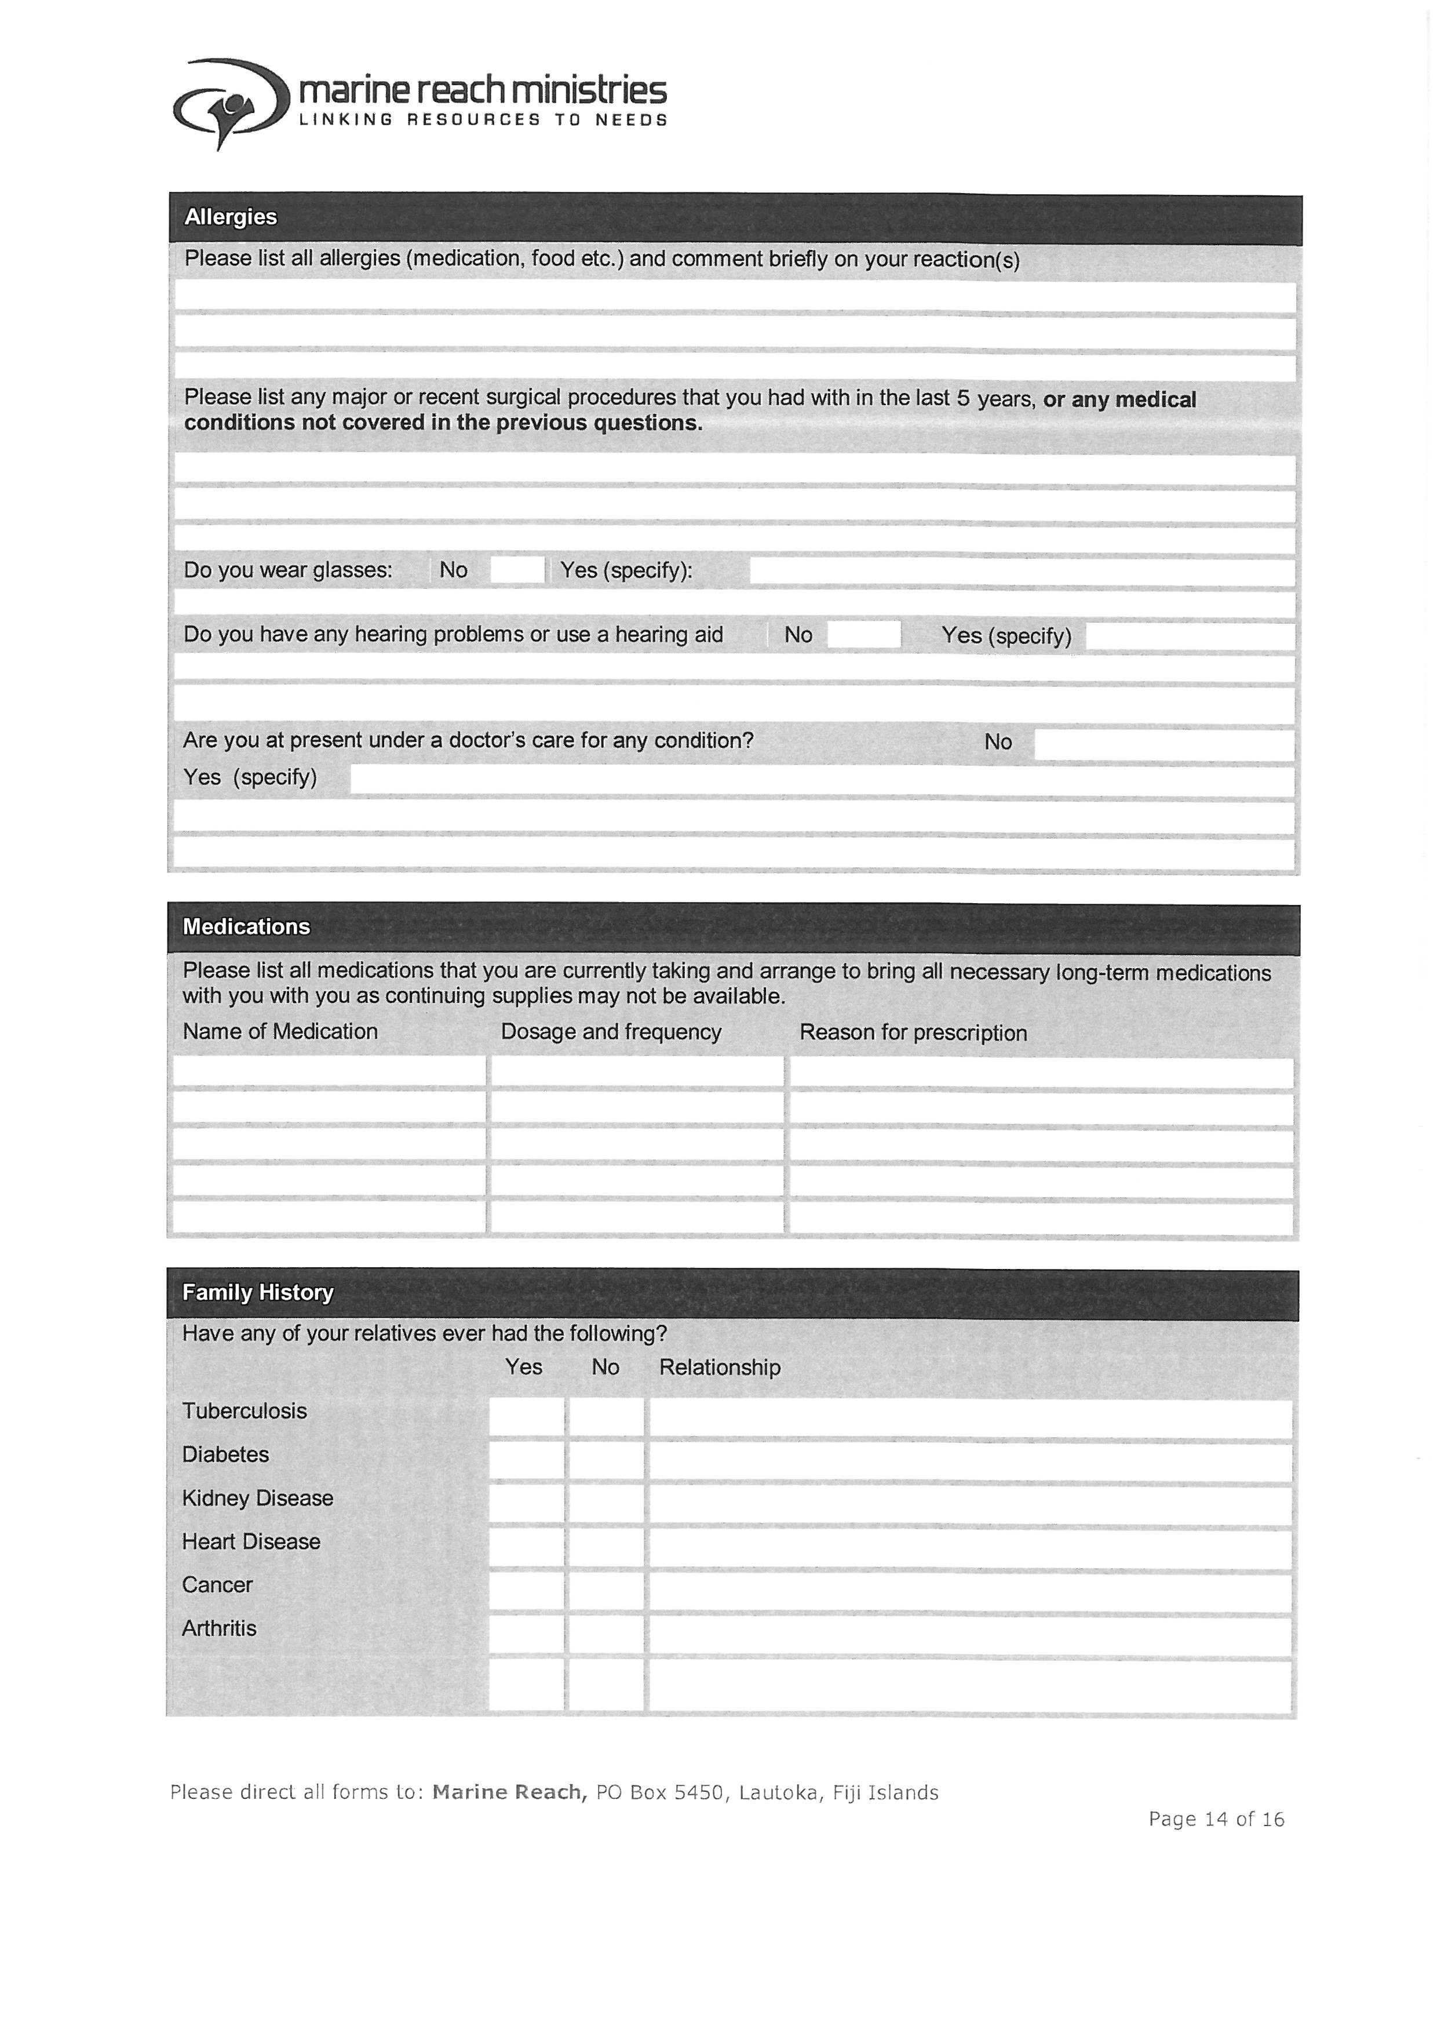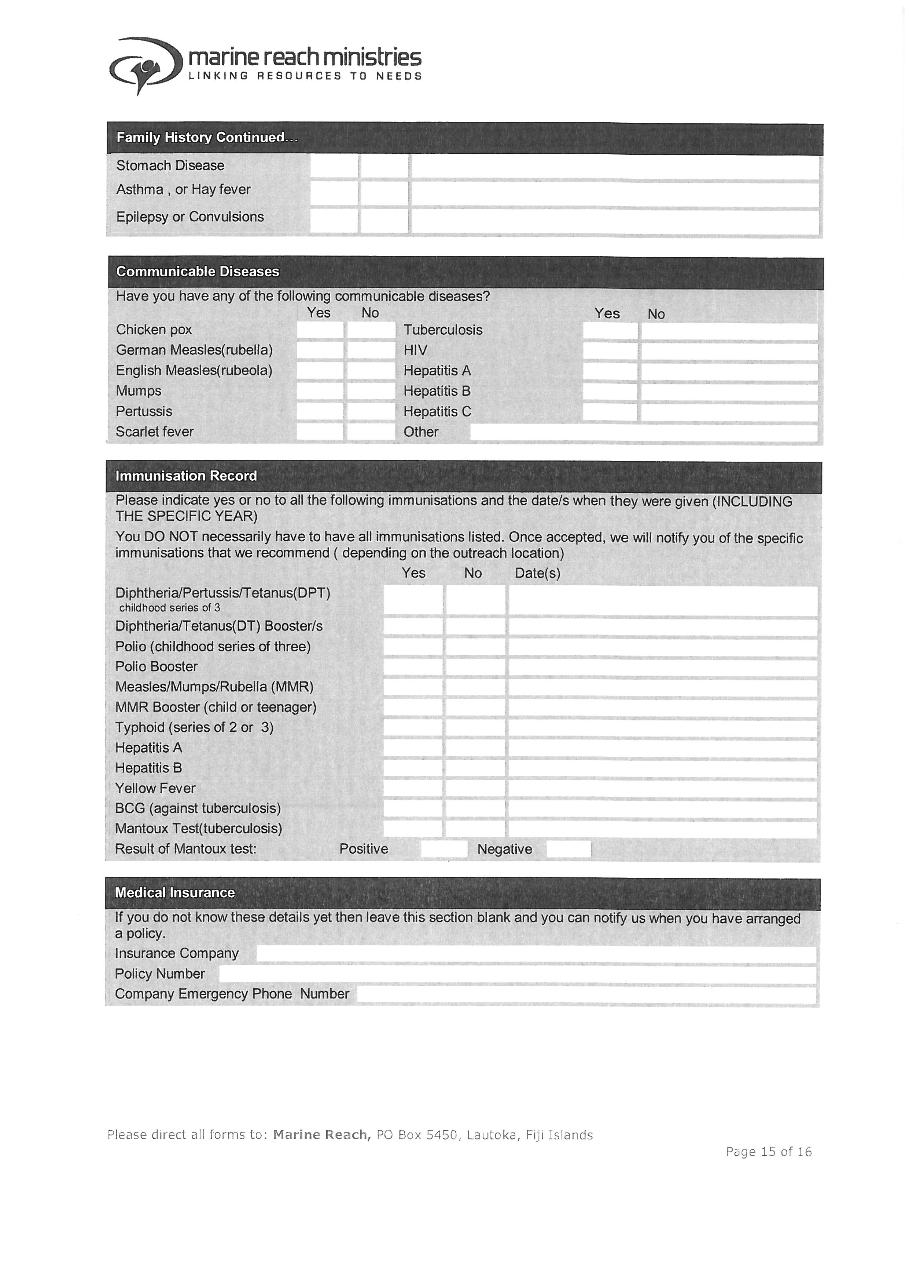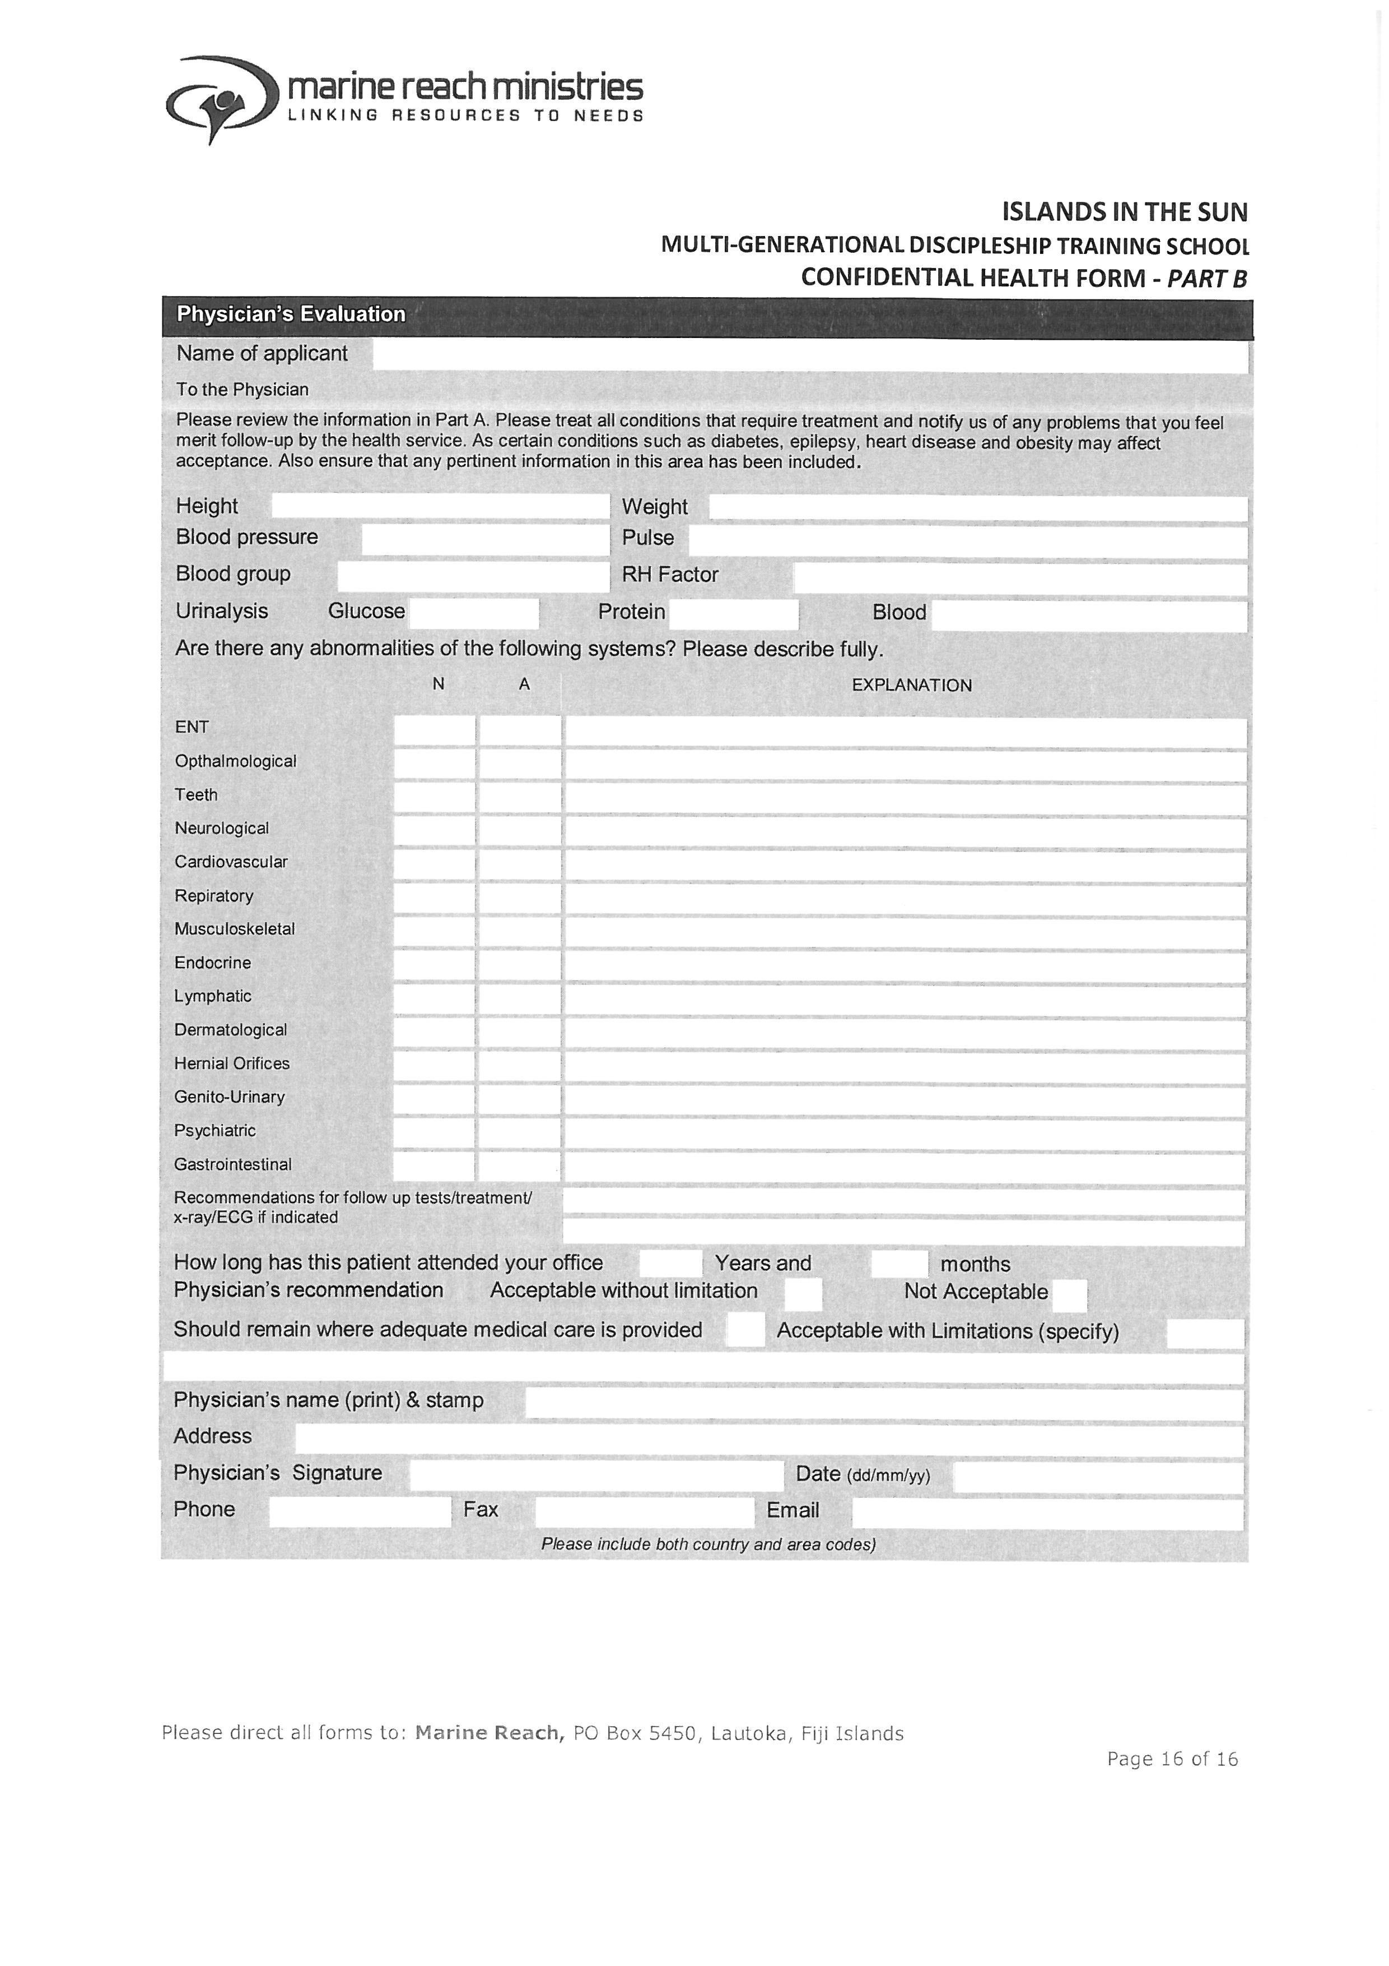

Financial Information

SOFM Lecture phase cost covers school fees, housing, food, transportation for school functions,

And honorarium for speakers and books. For those coming from nations that have much stronger

Economy will help train others of the lower economy nation students.

The school fees is $2,500 your currency.

There will be additional fees for the Outreach Phase and airfares. Please allow extra $2000.

Do you have your lecture fees now? Yes/No

If no, how do you plan to raise the money needed for the fees and outreach?
_________________________________________________________________________________________
__________________________________________________________________________________________

Do you currently have any outstanding debt with ywam bases?

International students may not arrive with a one way ticket. Therefore do you have the funds to

cover your round-trip airfares?
______________________________________________________________________________________________
Please give a contact name and number/email of a staff person at your previous base that can be

a financial reference.
______________________________________________________________________________________________
_____________________________________________________________________________________________

Please answer the questions on a separate piece of paper.

Personal History

1. State your reasons for applying. What is your ultimate purpose upon completion?

2. What is your commitment level to the daily activities and school work?

3. How has the Lord worked in your life during, and since your DTS? Describe what you have been

doing since your DTS (education, job, mission experience, etc.).

4. At which YWAM bases have you taken schools or been staff?

5 Describe your present relationship to your local church and leaders, and your involvement there.

Are they supportive of your involvement in mission work?

6. We encourage couples participating together in the course. Therefore are you prepared for your

Spouse to accompany you to this school?

7. Do you drink alcohol or use tobacco products? If yes are you willing to give this up while you are

on the YWAM Vunayasi base?

8. Please describe your relationship with your family? Are they supportive?

Missions.

1. Why do you feel you have a call to missions?

2. What is Gods calling in your life?

3. What is your specific time commitment to missions-short or long term?

4. Do you feel that you have a calling to another nation or other cultures? Explain

5. Are you pursuing a University of the Nations degree at this time? If so what degree?

6. Do you have any difficult situation to deal with in regard to attending this school? How can we
Pray for you?

7. If you were not accepted as part of this school, what would you do instead?

YWAM VUNAYASI FORM
REFERENCE FORM-PASTOR
Applicant: Fill in your name and sign below. Then give it to your pastor with a stamped envelope addressed to YWAM VUNAYASI P.O.Box 1450, Nadi,Fiji Islands.

Applicant’s name__________________________________________________________________________

Applicants Signature______________________________________________________________________

Date:____________________________________________________________________

The above applicant has applied to do a School Of Frontier Mission with YWAM Vunayasi, Nadi. YWAM is an international, interdenominational Christian missionary Organization existing to know God and make Him known. We would appreciate you filling out the form to assist us in assessing his/her suitability for the school. Serious consideration will be given to your comments. It will be kept confidential. Thank you for your help.

What is your relationship/role to the applicant? ________________________________________________

How long have you known the applicant? _____________________________________________________

How does the applicant respond to correction? __________________________________________________________________________________________
______________________________________________________________________________________________________________________________

In your opinion, is the applicant called to missions or Christian service? __________________________________________________________________________
________________________________________________________________________________________________________________________________

How does the applicant deal with relationships with the opposite sex?__________________________________________________________________________
_______________________________________________________________________________________________________________________________

Have you noticed tobacco or alcohol use?___________________________________________________________________________________________
______________________________________________________________________________________________________________________________

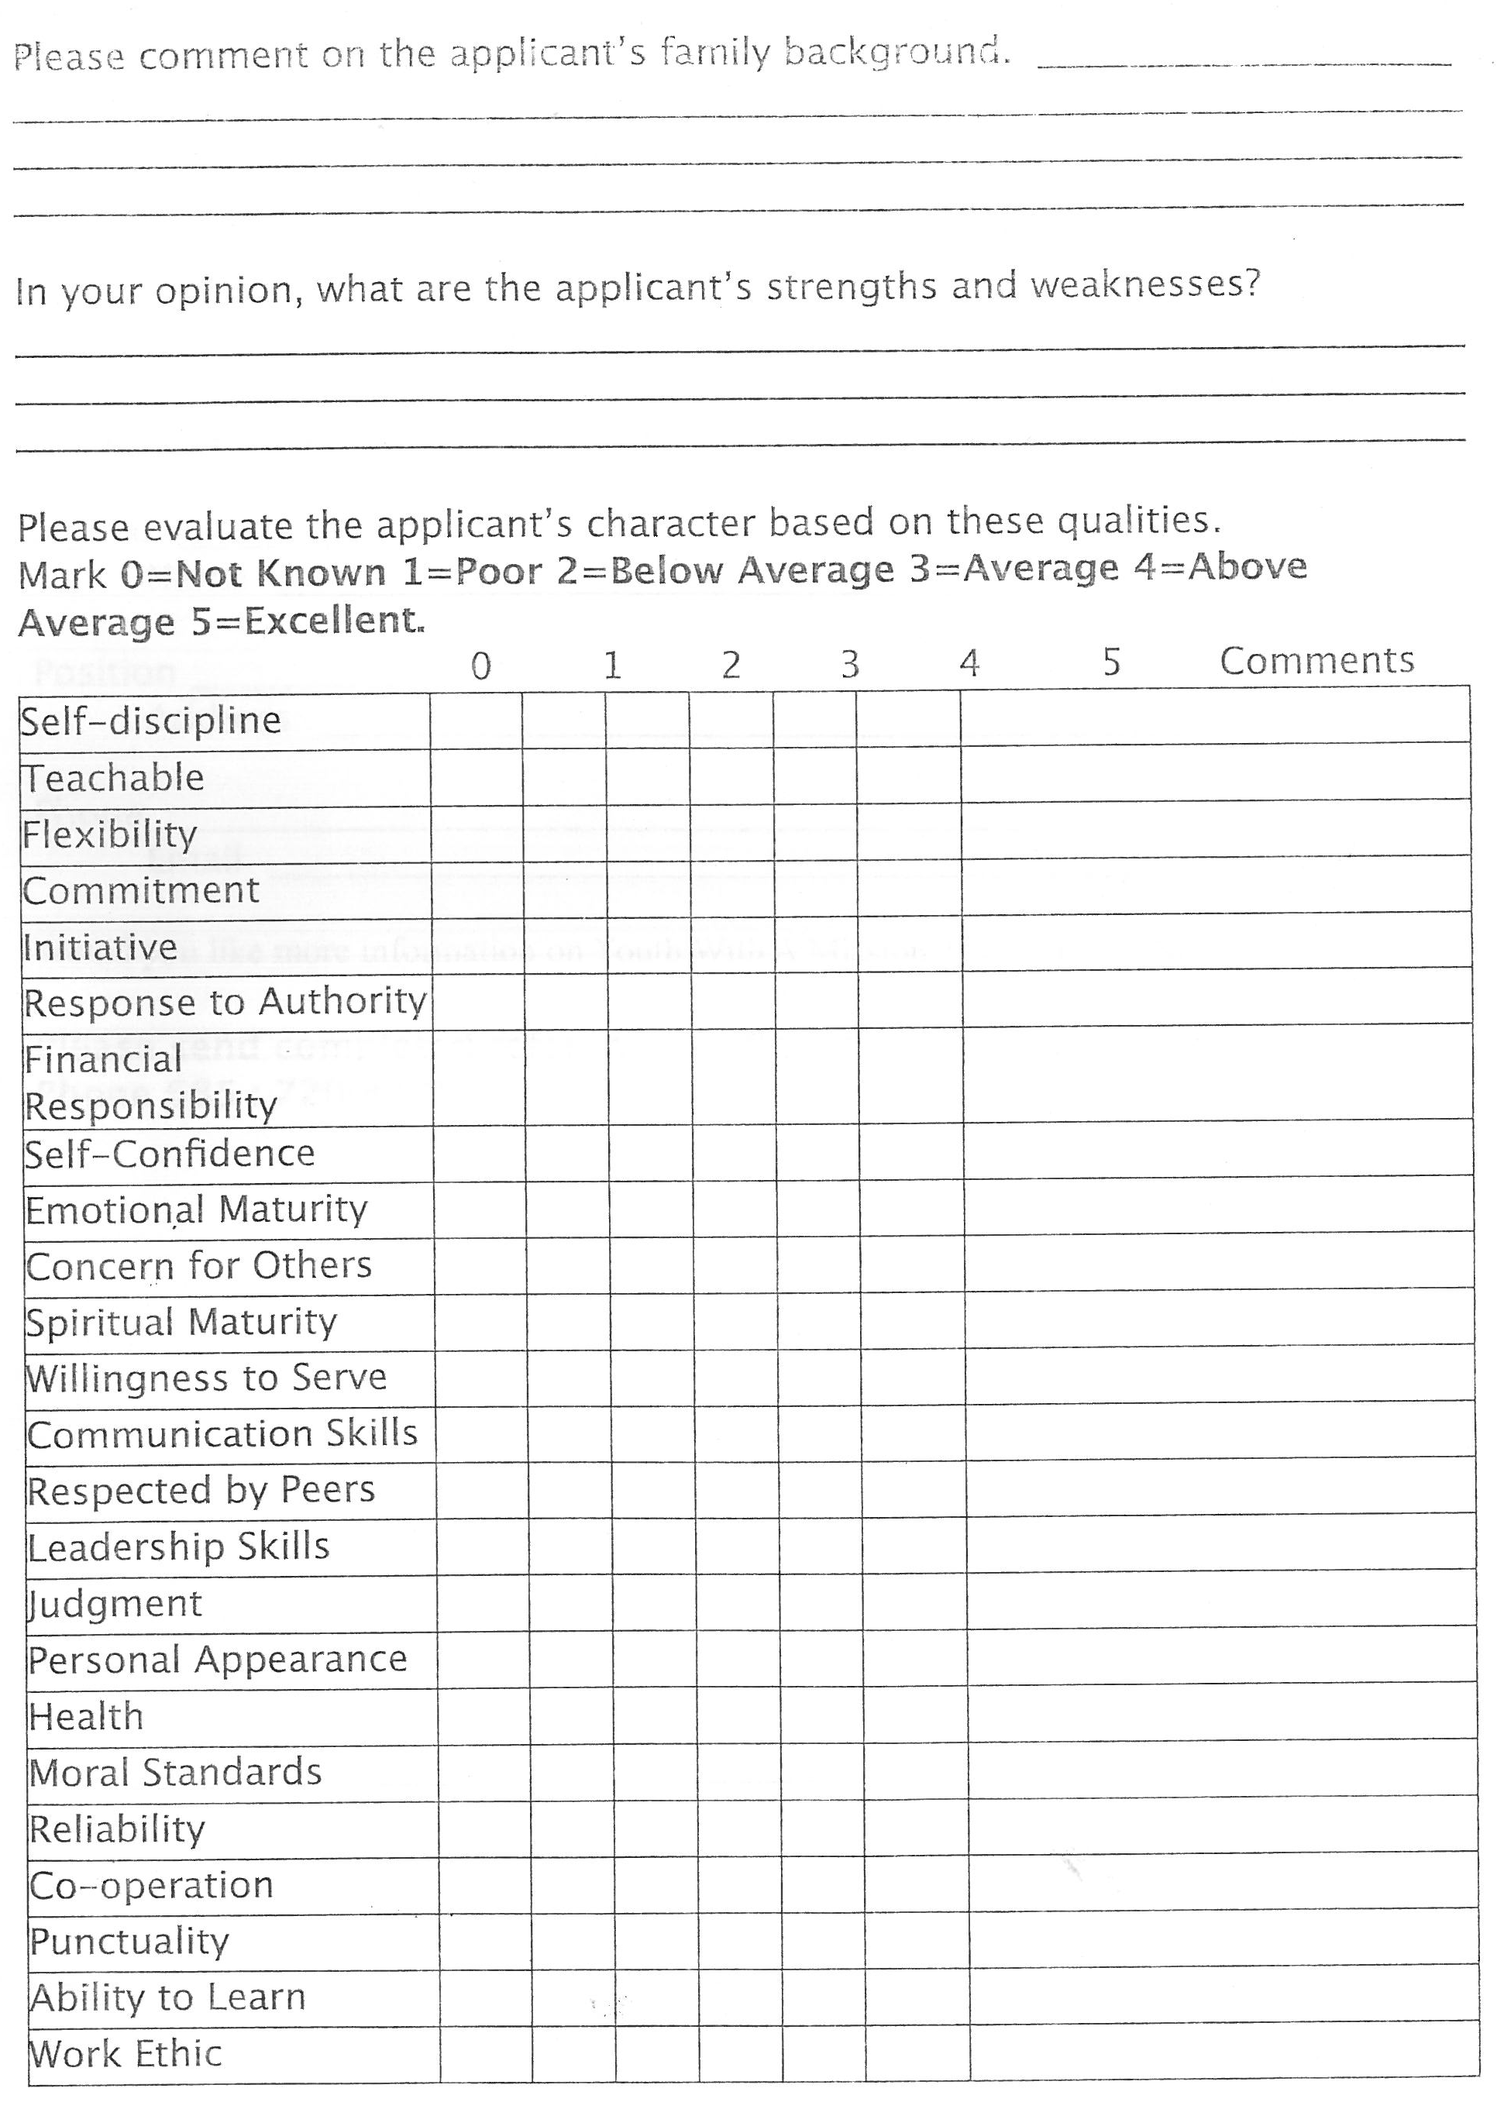

Please send your form to Ywam Vunayasi,P.O.Box 1450,Nadi Fiji Islands.

YWAM VUNAYASI FORM
REFERENCE FORM-YWAM LEADER
Applicant: Fill in your name and sign below. Then give it to your pastor with a stamped envelope addressed to YWAM VUNAYASI P.O.Box 1450, Nadi,Fiji Islands.

Applicant’s name__________________________________________________________________________

Applicants Signature______________________________________________________________________

Date:____________________________________________________________________

The above applicant has applied to do a School Of Frontier Mission with YWAM Vunayasi, Nadi. YWAM is an international, interdenominational Christian missionary Organization existing to know God and make Him known. We would appreciate you filling out the form to assist us in assessing his/her suitability for the school. Serious consideration will be given to your comments. It will be kept confidential. Thank you for your help.

What is your relationship/role to the applicant? ________________________________________________

How long have you known the applicant? _____________________________________________________

How does the applicant respond to correction? __________________________________________________________________________________________
______________________________________________________________________________________________________________________________

In your opinion, is the applicant called to missions or Christian service? __________________________________________________________________________
________________________________________________________________________________________________________________________________

How does the applicant deal with relationships with the opposite sex?__________________________________________________________________________
_______________________________________________________________________________________________________________________________

Have you noticed tobacco or alcohol use?___________________________________________________________________________________________
______________________________________________________________________________________________________________________________

Please send your form to Ywam Vunayasi,P.O.Box 1450,Nadi Fiji Islands.

